**TECHNICAL PROJECT REPORT**

# Title of Invention / Project:

# **VISITOR COUNTER WITH ULTRASONIC SENSOR**

# Team Members / Inventors:

|  |  |  |  |  |  |  |
| --- | --- | --- | --- | --- | --- | --- |
|  | **S. No.** | **Name** | **Department** | **Designation** | **Mobile** | **E-Mail** |
|  | 1. | Sahil Chaudhary | CSE IBM(C.C) | Student | 7087731311 | Chaudharysahil026@gmail.com |
|  | 2. | Raghav Khemka | CSE IBM(C.C) | Student | 9463784947 | [Khemkaraghav157@gmail.com](mailto:Khemkaraghav157@gmail.com) |
|  | 3. | Mayur Sharma | CSE IBM(C.C) | Student | 7088852071 | [Mayursharma474@gmail.com](mailto:Mayursharma474@gmail.com) |
|  | 4. | Gurdeep Singh | CSE IBM(C.C) | Student | 9870567632 | gs431695@gmail.com |
|  | 5. | Hardik lath | CSE IBM(C.C) | Student | 9816039042 | [hlath1234@gmail.com](mailto:hlath1234@gmail.com) |
|  | 6. | Khushal Thakur | ECE | Mentor | 9646030764 | khushal.thakur@cumail.in |
|  | 7. | Anshul Sharma | ECE | Mentor | 9478697475 | anshulsharma.ece@cumail.in |
|  | 8. | Kiran Jot Singh | ECE | Mentor | 9463909689 | kiranjotsingh.ece@cumal.in |
|  | 9. | Divneet Singh Kapoor | ECE | Mentor | 9878422653 | [divneet.ece@cumail.in](mailto:divneet.ece@cumail.in) |

**Section – 1 (IPR Related)**

# **Brief Abstract :**

Our project VISITOR COUNTER counts the entry and exit of a person in any hall or auditorium. This project will help us in telling how many people come to the hall or auditorium and how many people leave, it also tells us the total strength of people seated in the hall or auditorium. VISITOR COUNTER project can be used in Cinema halls, multiplex, malls, classrooms as well as in temples to count the number of person entering inside, so that when the maximum capacity of these places is reached other people can be stopped outside so that these places could not get over crowded to avoid congestion.

This project contains two ultrasonic sensor which sense the person moving inside or outside the hall or auditorium and gives the output to the LCD screen. The LCD screen shows the accurate no. of the people entered, exited, and total no. of people present in the hall or auditorium.

In this project further modifications can be done. We can do the following modification:

1. We can add a height measuring device which can measure the height of a person entering in hall and allocate him seat according to his height.

2. We can add an alarm system which will beep when maximum limit of persons that can enter the hall is reached.

# Existing state-of-the-art and Drawbacks in existing state-of-the-art

|  |  |  |
| --- | --- | --- |
| **S. No.** | **Existing state of art** | **Drawbacks in existing state of art** |
| 1 | **US7787656B2**. | The inherent problems of both people touching together and merge/split phenomenon can be overcome |

# Novel/Additional modifications that you can propose to improve upon drawbacks:

1. The merge-split problem can be solved by tracking each people pattern through analysing the HSI (hue/saturation/intensity) histogram in order to refine the early count.

# ADVANTAGES:

* Reduce the Human efforts to count the number of person
* Helps in stopping the place from being overcrowded by telling buzzing an alarm when maximum number of persons have entered the hall.

# Block DIAGRAM:

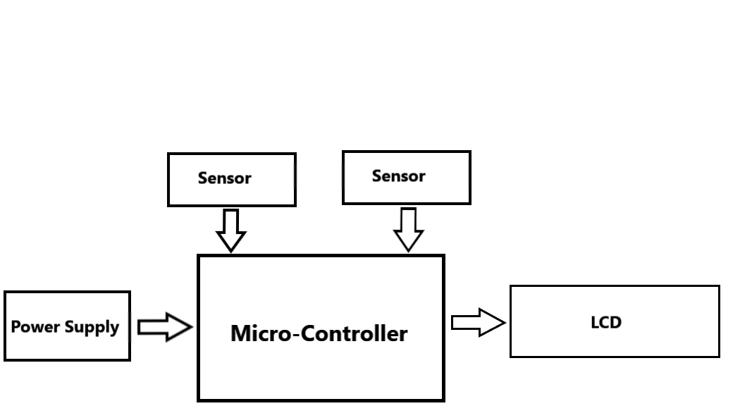

**Section – 2 (Real Project)**

# Materials Used -

|  |  |  |  |
| --- | --- | --- | --- |
| S. No. | Name of Product | Quantity | Cost |
| 1. | Arduino Uno | 1 | 450 inr |
| 2. | Ultrasonic Sensor | 2 | 350 inr |
| 3. | LCD display(20*4) | 1 | 499 inr |
| 4. | Jumper Wires | 18 | 126 inr |

# Circuit Diagram

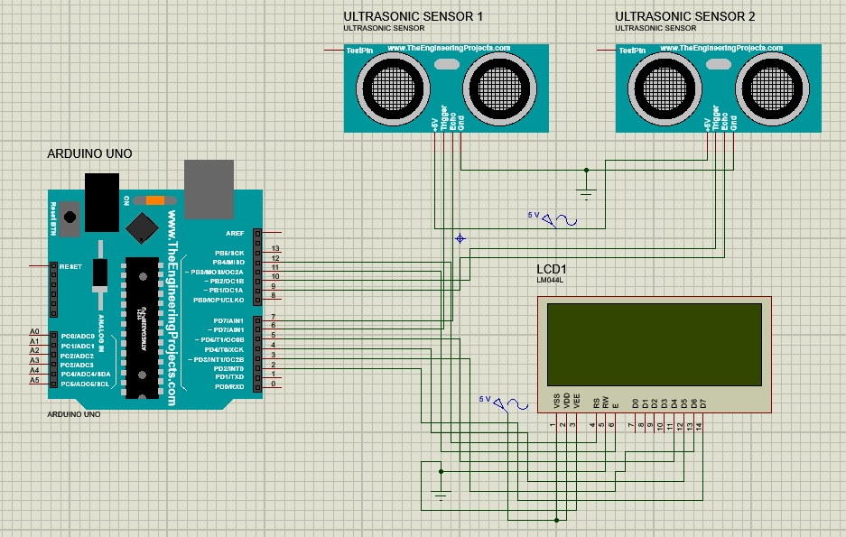

# **Steps of Circuit Completion**

* **For making this circuit we will need :**

1. 1x Arduino Uno
2. 2x Ultrasonic Sensor
3. 1x LCD(20*4)
4. 18x Jumper Wires

* **Now we will connect ultrasonic sensors with Arduino Uno**

\

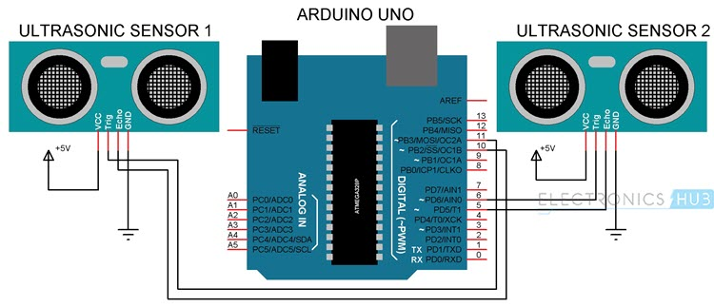

* **After doing this connection we have to connect Lcd (20*4) with Arduino-Uno**

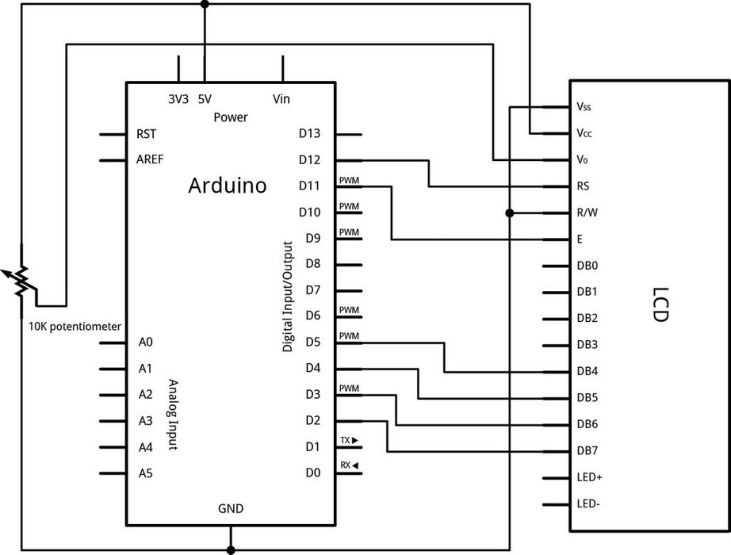

# After this we have to connect Arduino with power source

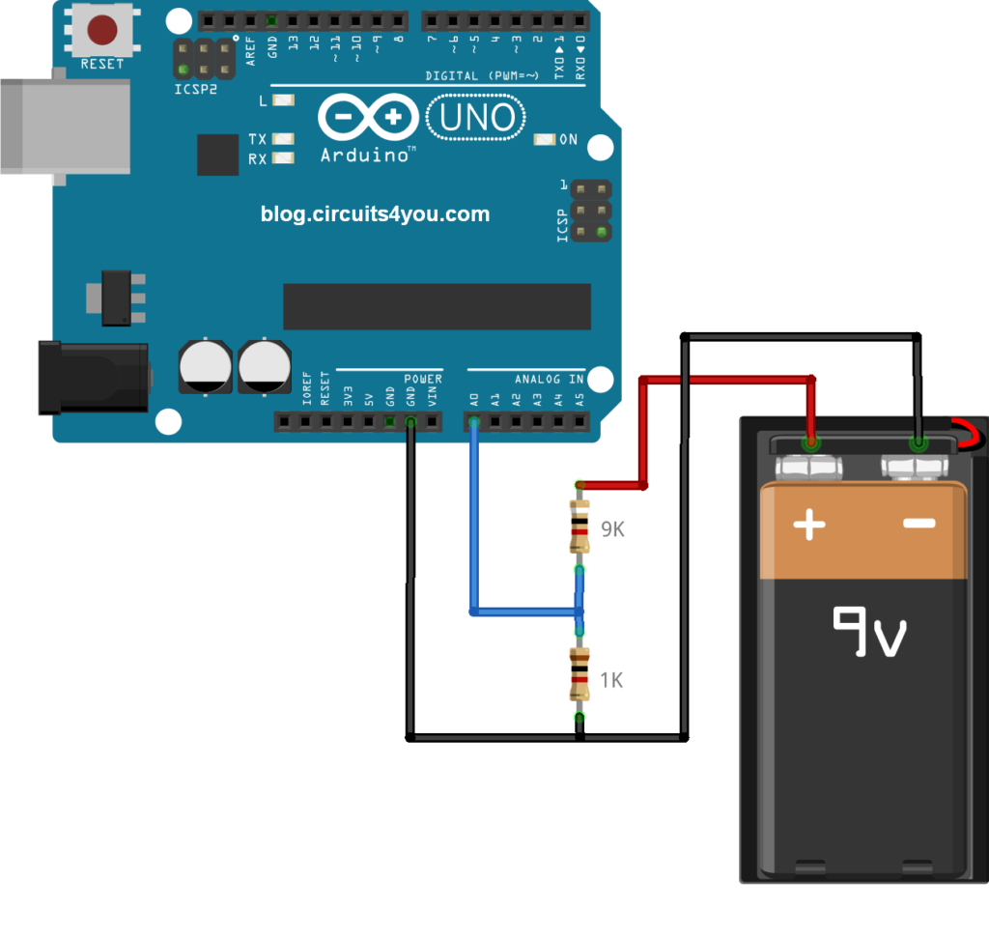

# Now upload the code to Arduino Uno and check whether the circuit is working or not.

# Program Code

**https://github.com/mayursharma474/visitorcounter**